**Assignment 3:**

Create IAM user and give full access to S3.

The steps of creation are as follows:

1. Search for “**IAM**” in the search bar and then click on **“IAM-Manage access to AWS resources**”

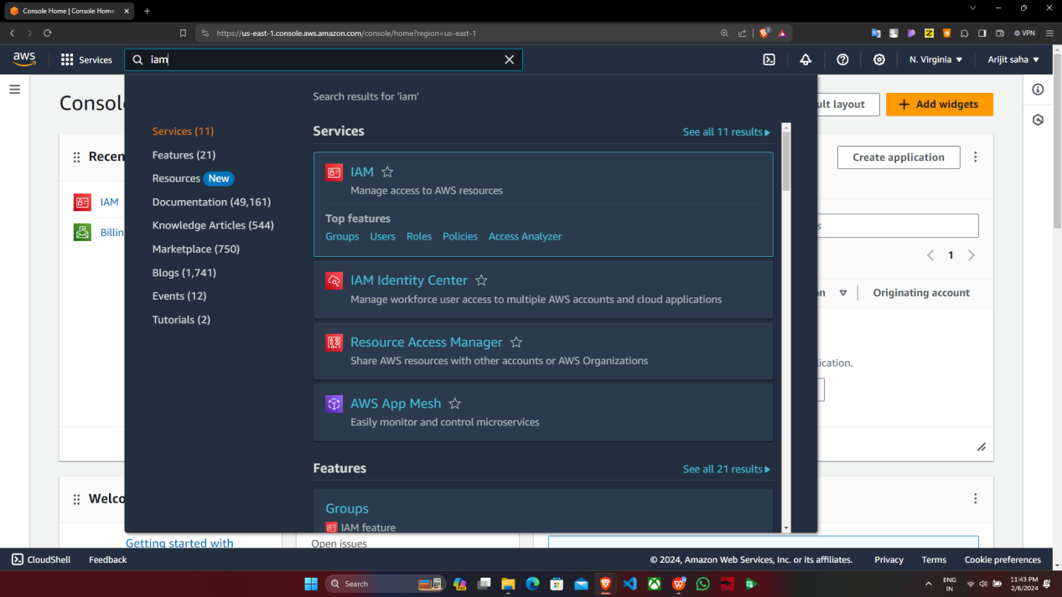

1. Navigate to the left side bar then **click on “Users” under “Access management”** section.

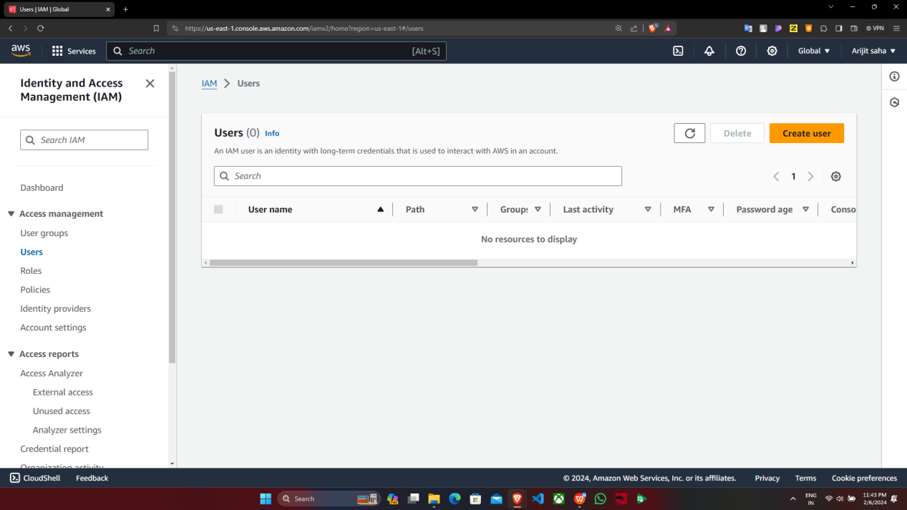

1. Then we have to click on “Create user” option.

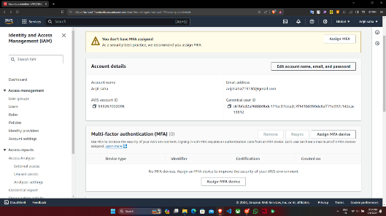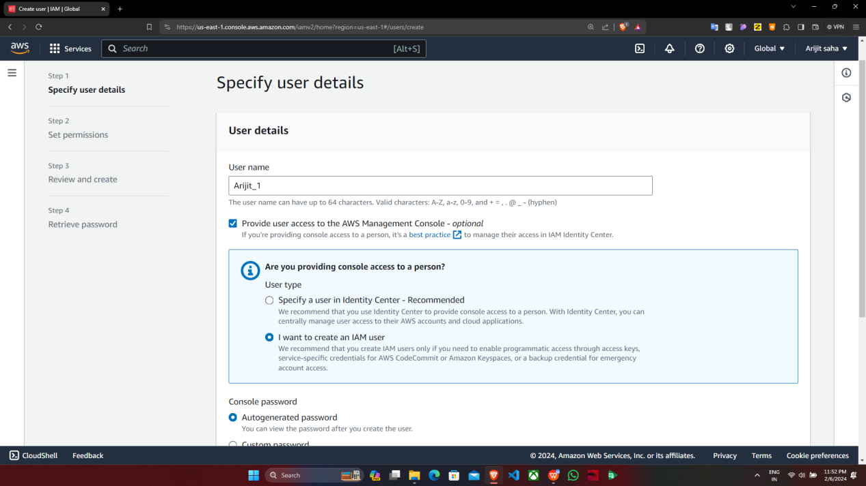

Supriyo-1

1. Now we are in step 1(i.e. Specify user details) of creating an IAM user. We have to enter the username and then click on checkbox which will provide user access to the AWS Management Console. After that we select “**I want to create an IAM user**” option.

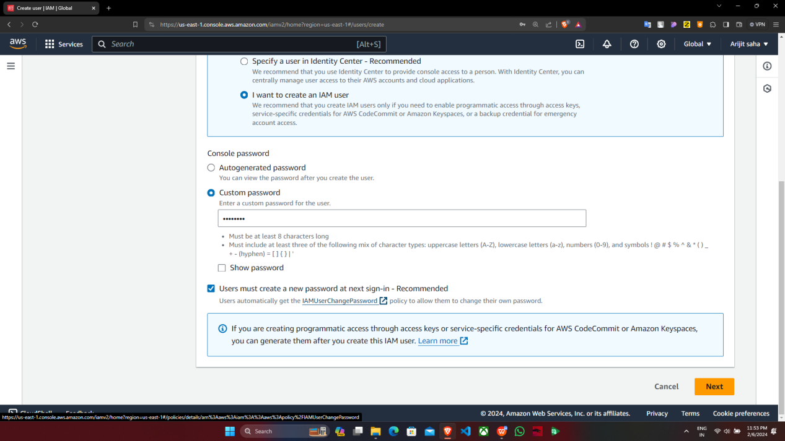

1. Then we select the option of creating a **custom password** and enter password according to our choice. Then we deselect the checkbox stating “**Users must create a new password at next sign-in”. Then we click on “Next”.**

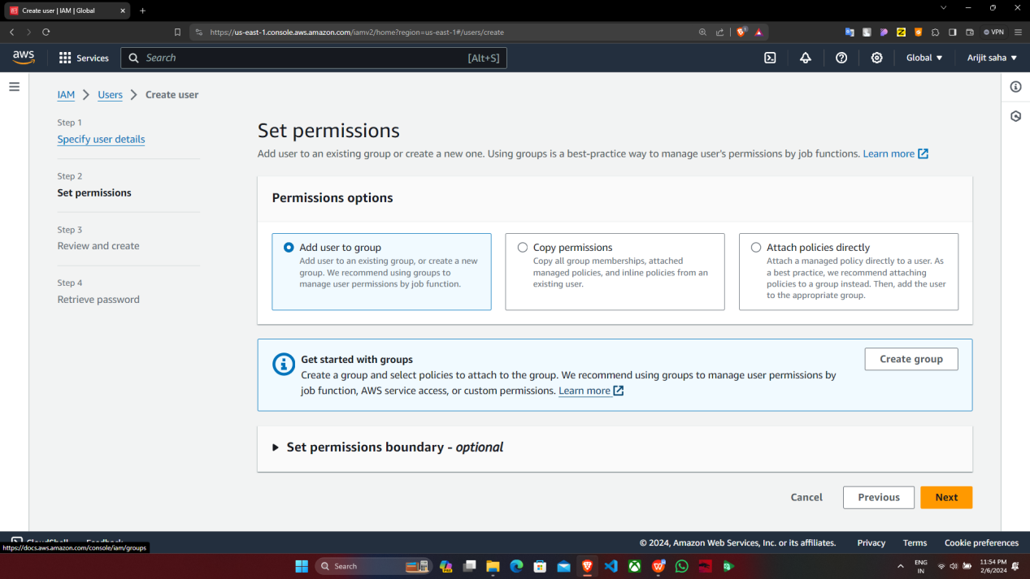

1. Now we are in step 2(i.e. Set permissions). Here we select the option of “Add user to group” and then click on “Create group” option.

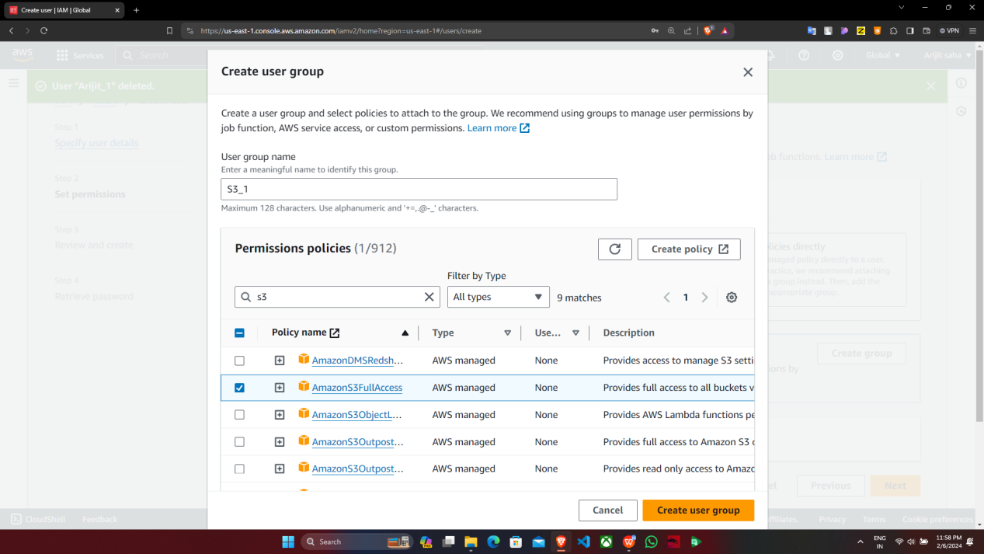

1. Now we get a “Create user group” window prompt. We have to provide the name of the group, let’s say**”S3_1”.** We search for s3 in permission policy search bar and then select the checkbox (i.e. the permission policy option) which will give full access to **s3 (here it is AmazonS3FullAccess)**. Then click on “Create user group” option

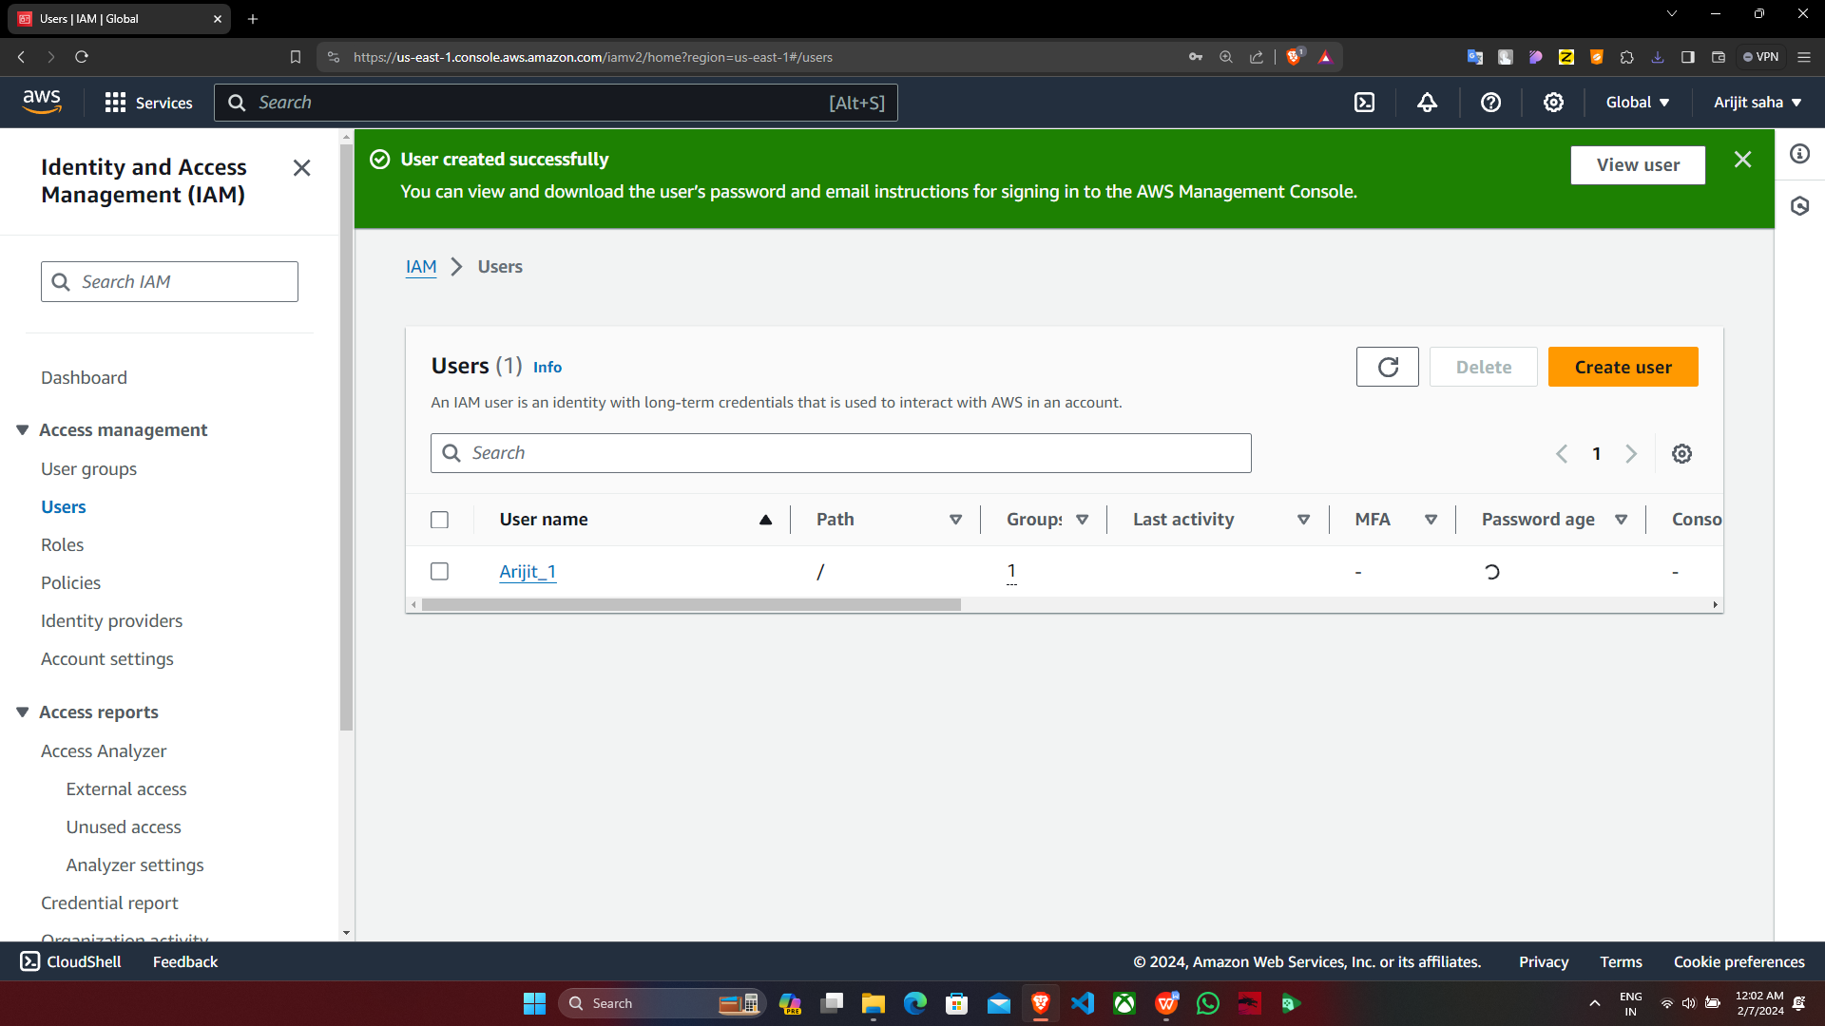

Supriyo-1

8.We will be able to see that user group of having full access to s3 has been created. Now we click on “Next”

9.Now we are in step 3(i.e. Review and create). We see that in Permissions summary section the IAM user created has been assigned to “S3_1” group. We click on “Create user” to proceed further.

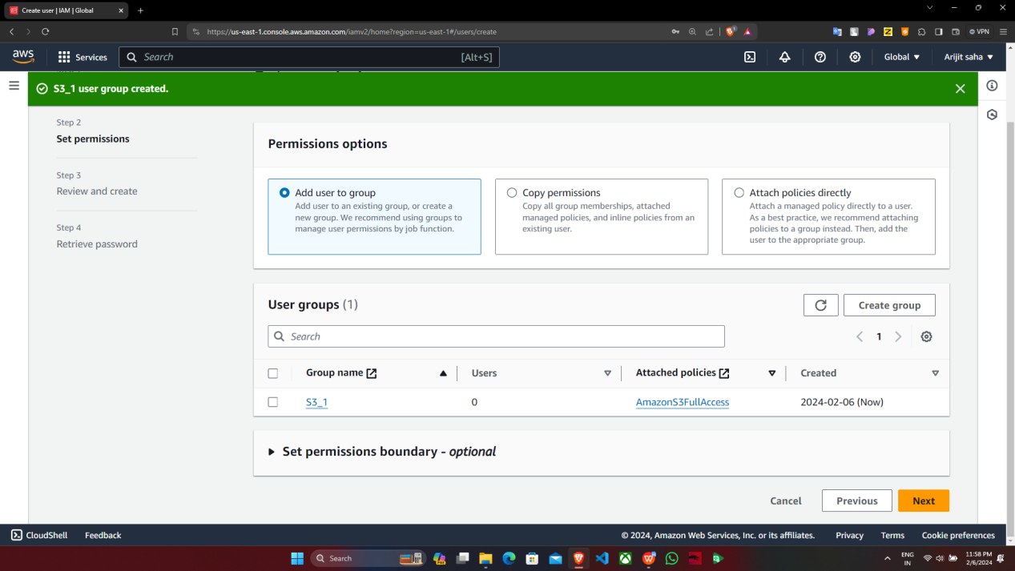

1. Now we are in step 4(i.e. Retrieve password) which will provide us with the sign in credentials of IAM user. We can download the .csv file containing sign in credentials or directly view it from here itself. Then click on “Return to users list”.

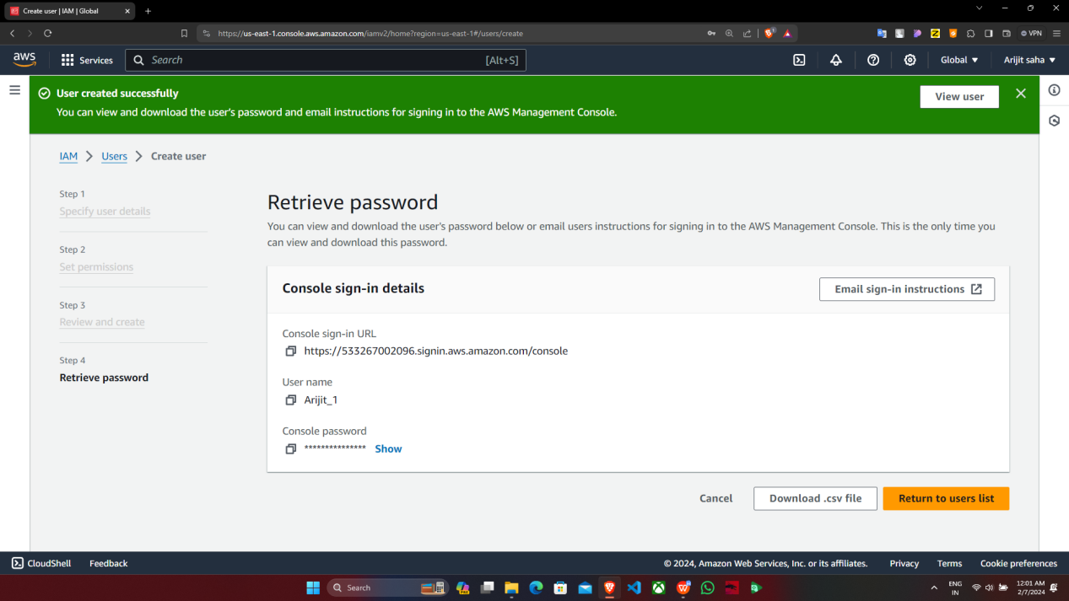

Supriyo-1

1. Now we will see in User’s list that IAM user having full **S3_1 has been successfully created.**



Supriyo-1

1. Now we need to sign out and sign in using **IAM user credentials.**

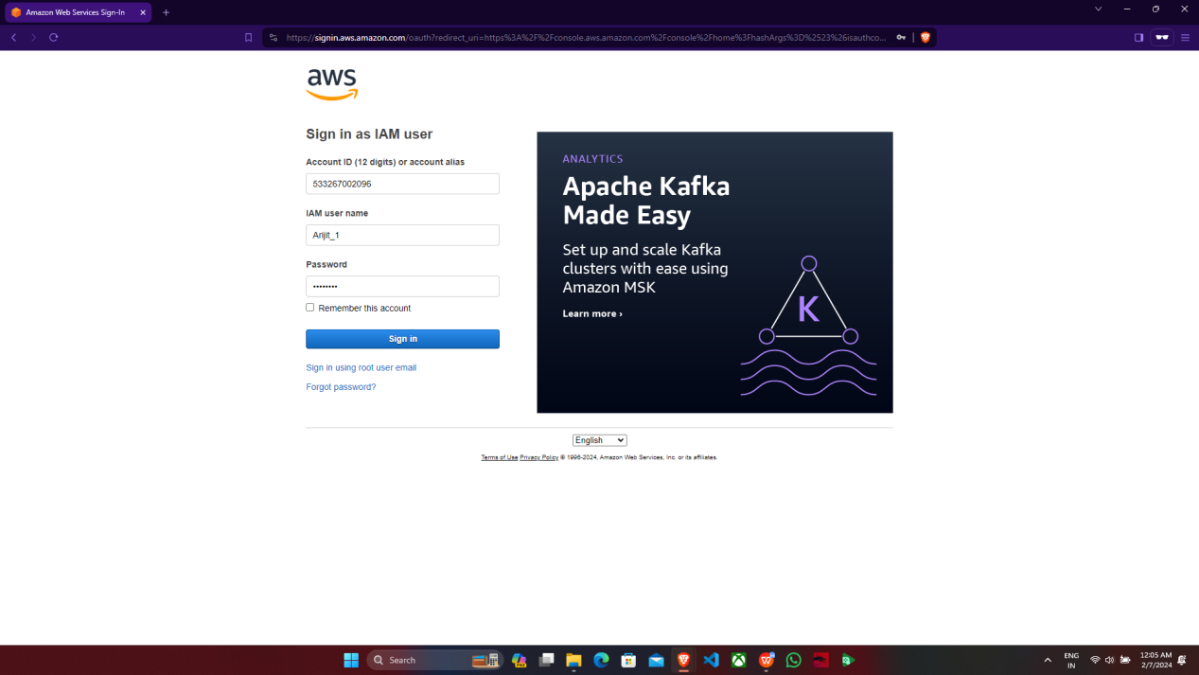

Supriyo-1

1. We will verify that whether it has s3 access or not. Fortunately, we will see that **it has full access to s3 only but other services**’ access will be denied.

